AGENDA
TOWN OF VIENNA
October 27, 2025

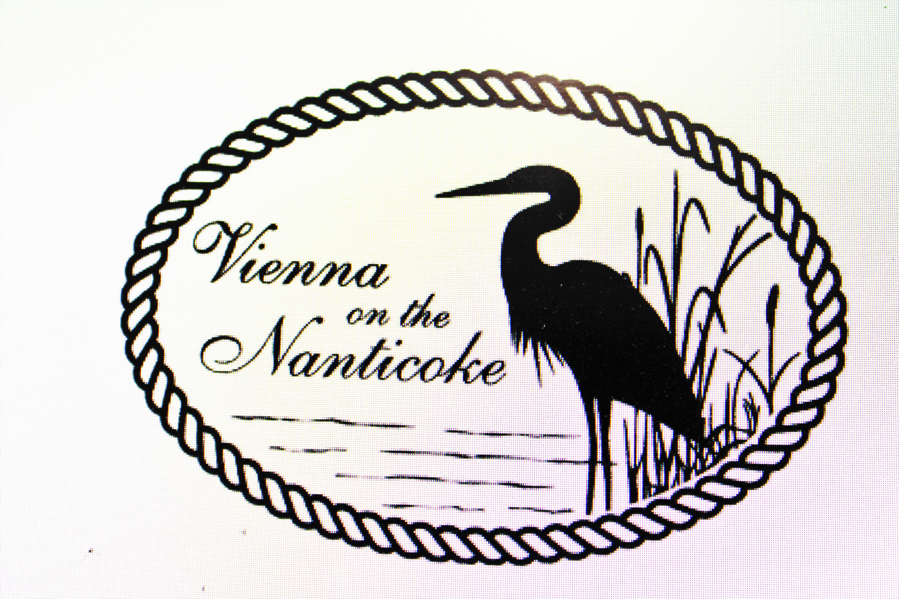
VIENNA, MARYLAND

VIENNA, MARYLAND

VIENNA, MARYLAND
7 P.M.

I. Call the Meeting to Order
II. Additions to Agenda and Agenda Approval
III. Appropriate Action on Minutes of September 8, 2025
IV. Committee Reports

A. Clerk’s Report
B. Planning & Zoning Commission
C. Code Enforcement
D. Public Works
E. Water & Sewer

V. Old Business:
A. ENR Upgrade on hold – GMB – land acquisition – Title Search Update?
B. Lawn and Property maintenance – follow up on proposed ordinance and the proper verbiage
C.

VI. New Business:
- Booking a one-day rental of the Gazebo - Policy
B. Opioid Restitution Fund Annual Report – is this worth filing? – Time vs. Money received
C. Nause-Waiwash Band of Indians - The town received two official citations from Senator Mautz and the Nause-Waiwash Band of Indians; and an Accommodation from the Dorchester County Council. Attendance was at an all-time high with 2,500 attendees.
D. Pie Shop – 115 Ocean Gateway – floor needs repairs
E. Snow Removal Contract (Greg Cusick) – up for renewal for four years
F. Thank you to Greg Cusick for the donation ($500 – bush hog the area where the fireworks were set up)
G. Holiday Schedule
H. Raise fee for water and sewer hookup for new construction
I. Mayor and Commissioners will be reviewing the National Property Code
J. UHY Audit request
K. Many citizens have inquired as to when the Hometown Heroes banners will be installed.

VII. Public Comments:

VIII. Reading of the Bills:

IX. Adjournment:

X. No Closed Session:

XI. Next Meeting: November 10, 2025

The Commissioners reserve the right to close a portion of this meeting as authorized by Section 3-305(b) and Section 3-104 of the General Provisions Article of the Annotated Code of Maryland. NOTE AGENDA POSTED ON BOARD IN TOWN HALL ON DAY OF MEETING.

