Public Hearing: April 27, 2026 @ 7:00 PM, Vienna Town Hall, 214 Market St Vienna, MD 21869. The Commissioners of Vienna will hold a public on charter amendment resolution NO. 2026-01, which is designed to clarify or broaden the Towns general obligation borrowing powers, including removing references in the prior text of Charter Section 22-41 to bond anticipation notes and notes in anticipation of other sources of revenue.
AGENDA
TOWN OF VIENNA
April 27, 2026
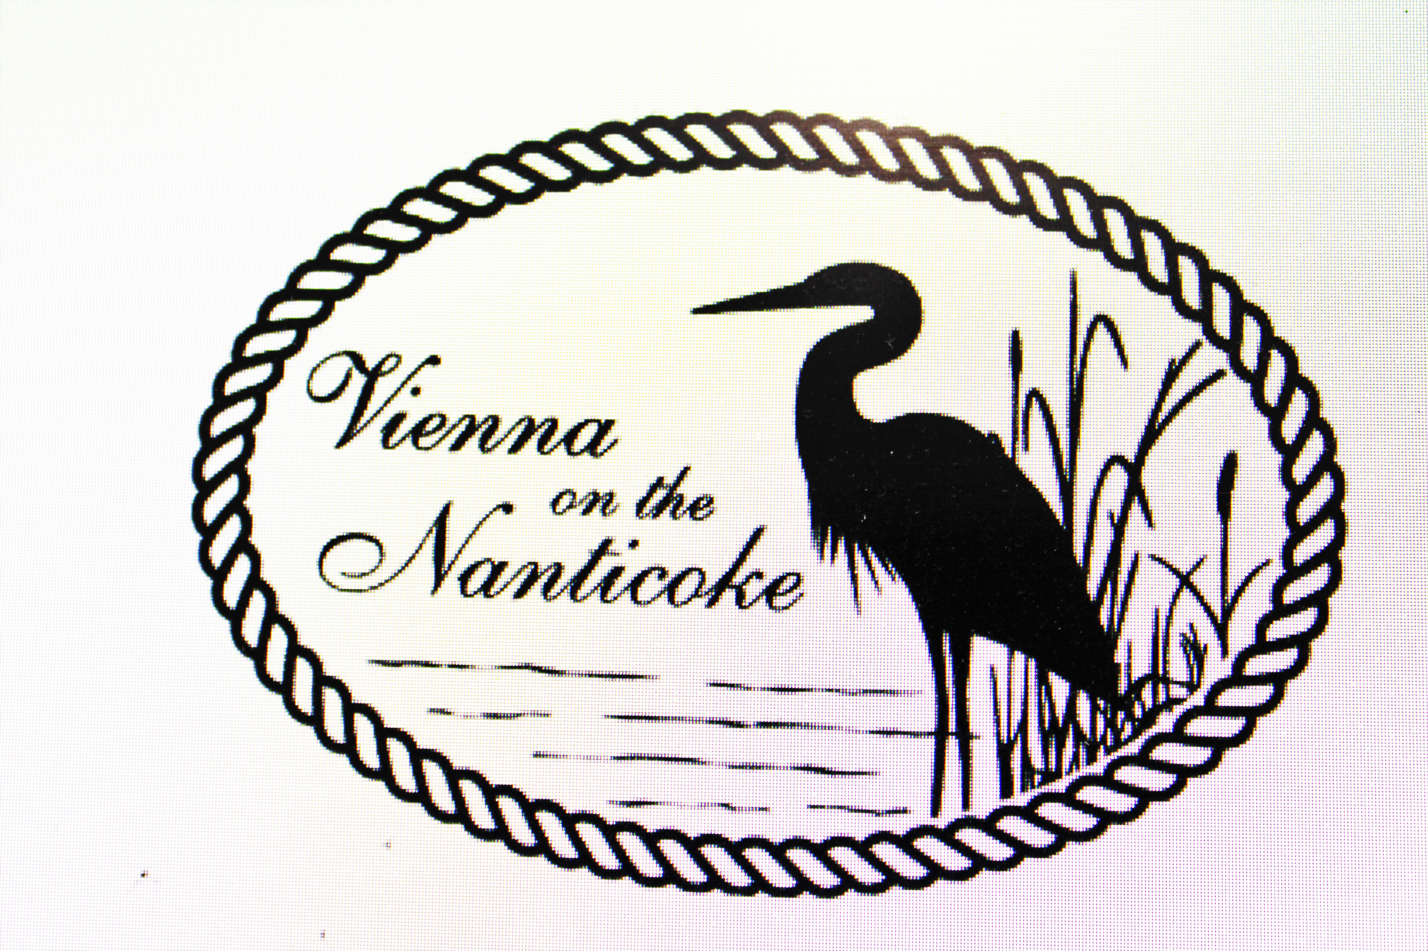
VIENNA, MARYLAND

VIENNA, MARYLAND

VIENNA, MARYLAND

7 P.M.
I. Call the Meeting to Order
II. Additions to Agenda and Agenda Approval
III. Appropriate Action on Minutes of April 13, 2026
IV. Committee Reports
A. Clerk’s Report
B. Planning & Zoning Commission
C. Code Enforcement
D. Public Works
E. Water & Sewer
V. Old Business:
A. ENR Upgrade on hold- land acquisition- Title search update WWTP-
B. Lead Service Lines- Commissioner Fluharty
C. Hebron Savings Bank- Christopher Cooper- Payment Terminal updates
D. Ball Field Usage- no new updates from teams
E. George B Todd Grant- Digitizing Town Documents
F. GMB Water Treatment Plant-
G. MDIA- Middle Department Inspection Agency- Email sent to MDIA to set up meeting requests by Commissioners and Mayor. Pending response.
H. Spring Clean-up- April 18, 2026 -called to have dumpster picked up 4/27/26
I. Water/ Sewer hook- up rate Ordinance 2026-1 –Second Reading
Sent to Star democrat 4/22/2026 for posting- Posted 4/25/26 SD
J. Chesapeake Waste- New trash cans have been exchanged for broken cans.
K. Mayor and Commissioner Terms- 2-to-4-year terms.
L. NRG Energy- Water Usage

VI. New Business:
- Bond Counsel – Pete Golba- Water Treatment Plant- Publication Star Dem- 4/1/26
  - Public Hearing 4/27/2026- Town Hall 7:00 PM
- Mr. Murphy- Re. Parade
- Katherine Cain- Temp. Town Management Grant
- LESMA Meeting- May 21,2026- Hurlock, Suicide Bridge 6:30 pm
- Water tower washout- Southern Corrosion.
- 116 Water St- Statements of Intent of public use
- Community legacy grant for improvements - closed 4/15/2026
- Hebron E- statements- set up Charging $3.00 per statement & more secure
- Budget 2026-2027
- Fallen Banners
- LGIT Reminder: Playground safety inspection
- Ordinance 2023-3 Moratorium single family homes to be lifted- Started June 12,2023 – Linden Ln.
- Lot sizes and setbacks-
- June 11, 2026- V.E.S. Request Gazebo for 5th grade promotion picnic/ BBQ

Public Comments:
VIII. Reading of the Bills:
IX. Adjournment:
X. Closed Session:
XI. Next Meeting: May 11, 2026

The Commissioners reserve the right to close a portion of this meeting as authorized by Section 3-305(b) and Section 3-104 of the General Provisions Article of the Annotated Code of Maryland. NOTE AGENDA POSTED ON BOARD IN TOWN HALL ON DAY OF MEETING.

